DBS301 Lab 6 – Printouts only incl. SELECT statements and RESULTS with the Cover Page

Due on Monday, March 12th by 2pm
.
- Display last name, job title and department number for all employees who work in the same department as Zlotkey. Exclude him from this query.

select last_name, job_id, department_id
from employees
where department_id = (select department_id from employees
where (last_name like '%Zlotkey%') )
and last_name not like '%Zlotkey%';
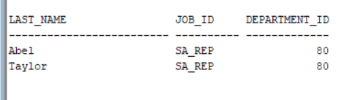

- Display last name, salary and hire date for all employees hired after Davies
if they earn more than Grant. Sort the output by the most recent hire date.
select last_name, hire_date
from employees
where hire_date > (select hire_date from employees.
where (last_name like '%Davies%'))
and salary > (select salary from employees
where (last_name like '%Grant%'));
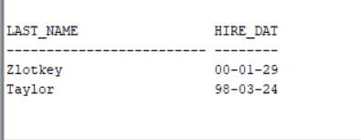

- Display city, province name and postal code for all departments located in countries whose name contains C or c. If the province is blank, show message Unknown and the heading should be Province.
Sort the output by city ascending. Do NOT use Join method.

select city, nvl(state_province,'Unknown') "Province", postal_code
from locations
where country_id like 'C%' or country_id like 'c%'
order by city;
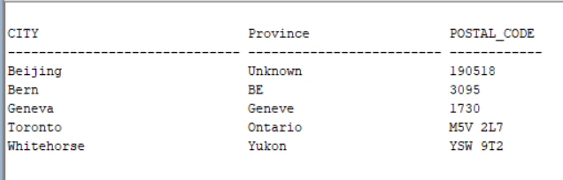

- Display last name, job title and salary for all employees who earn more than the highest salary in the ACCOUNTING department. Do NOT use Join method.
Sort the output by top salaries first and then by job_title.
select last_name, job_id, salary
from employees
where salary > (select max(salary) from employees
where department_id in (select department_id
from departments
where department_name = 'Accounting'
))
order by salary desc, job_id;
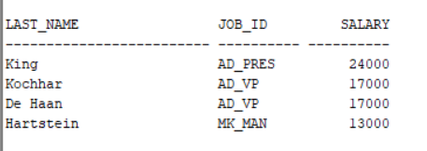

- Display last name, job title and salary for all employees whose salary matches any of
the salaries from the SALES Department. Exclude people who are Sales Reps.
Do NOT use Join method.
Sort the output by salary ascending first and then by last_name.
select last_name, job_id, salary
from employees
where salary = (select salary from employees
where department_id in (select department_id
from departments
where department_name = 'Sales'
)and job_id not like 'SA_REP')
order by salary, last_name;
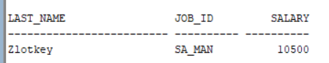

- Display last name and salary for all employees who earn less than the average salary in all departments.
Sort the output by top salaries first and then by last name.
select last_name, salary
from employees
where salary < all(select avg(salary) from employees
)
order by salary desc, last_name;
